Design Document for SLAP
1. Overview
The following are the basic classes and action:

 | Class | Principle Responsibility
1 | Security | Manages user validation
2 | Project | Manages actions regarding a project
3 | Groups | Manages actions regarding groups
4 | Course | Manage actions regarding course
5 | Message | Manages actions regarding communication
6 | SLAPs | Manages actions regarding SLAPs
7 | Account | Manages actions regarding accounts
8 | Evaluations and Submissions (EvalSub) | Manages actions regarding evaluations and submissions
9 | GUI | Manages the graphical user interface

Actions:
 | Action
1 | Validate/Register User
2 | Create/Delete/Edit Projects/Course
3 | Assign/Edit/Delete Groups
4 | Create/Edit/Save/Send Message
5 | Change/Reset Password
6 | Create SLAP, Instructor to Student, Administrator to All, Administrator to Instructor
7 | Submit Evaluations/Assignments
2. System Structure
The following is a description of the final structure.
  - Inheritance Structure
The following is a possible inheritance structure.
Account

Password
User

Fig 2.1.1: Possible Inheritance
  - Aggregations
The following is a logical structure of Account displaying aggregation between classes.

Account

1
m
Course

1
m
Project
1
m
Groups

Fig 2.2.1: Aggregation Structure
  - Associations
We have organized and planned out the association between classes in the process of modeling the principle actions.
Example: Classes (with aggregations and associations) involved in the principle action Create/Edit/Delete Project/Course
SLAP
GUI

Security

+validate(…): boolean

Account

Course
+createCourse(…):boolean
+editCourse(…):boolean
+deleteCourse(…):boolean

Project
+createProject(…):boolean
+editProject(…):boolean
+deleteProject(…):boolean

Groups

Fig 2.3.1: Class diagram showing association for action Create/Delete/Edit Project/Course
  - Complete class diagram
The following is a class diagram displaying all major actions with association and aggregation.
SLAP Class Diagram
Security

+validate(…): boolean
Message
+message:String
+createMessage(…):boolean
+editMessage(…):boolean
+saveDraft(…):boolean
+sendMessage(…):boolean
+cancelMessage(…):boolean
+viewMessage(…):boolean
+closeMessage(…):boolean
GUI
+createGUI(…):void

Account
+username:String
+password:String
+changePassword(…):boolean
+resetPassword(…):boolean
+registerUser(…):boolean
+reorganizeContacts(…):boolean

SLAPs
+InstructortoStudentStatement:String
+AdmintoAllStatement:String
+AdmintoInstructorStatement:String
+createInstructortoStudent(…):boolean
+createAdmintoAll(…):boolean
+createAdmintoInstructor(…):boolean
+editInstructortoStudent(…):boolean
+editAdmintoAll(…):boolean
+editAdmintoInstructor(…):boolean

Course
+courseName:String
+courseCode:String
+createCourse(…):boolean
+editCourse(…):boolean
+deleteCourse(…):boolean
+viewCourse(…):boolean

Project
+projectName:String
+createProject(…):boolean
+editProject(…):boolean
+cancelProject(…):boolean
+discardChange(…):boolean
+viewProject(…):boolean
+uploadDocument(…):boolean
+viewDocument(…):boolean
+closeDocument(…):boolean
+cancelView(…):boolean

Groups

+assignGroup(…):Boolean
+editGroup(…):Boolean
+deleteGroup(…):Boolean
+viewActivity(…):boolean

EvalSub
+viewSubmissions(…):boolean
+viewSubmissionHistory(…):boolean
+submitEvaluations(…):boolean
+submitAssignments(…):boolean

Fig 2.4.1: Class diagram showing all classes and associations in the system
3. System behavior
The behavior of the system is based on the interactions between the classes involved in each principal action. The following are final diagrams.
3.1. Principle Action: Validate User
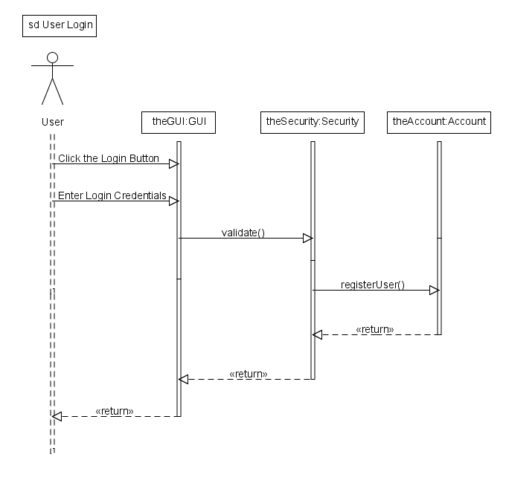
Fig 3.1.1: Sequence diagram for principle action Validate User

3.2. Principle Action: Create/Delete/Edit Project/Course/Groups

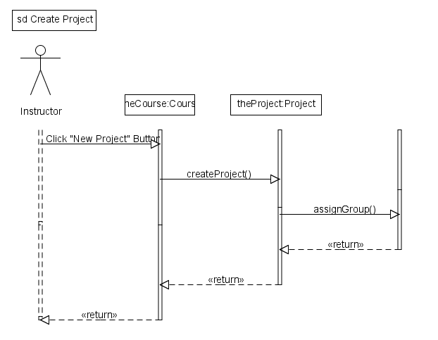
Fig 3.2.1: Sequence diagram for principle action Create Project and Assign groups

3.3. Principle Action: Create/Edit/Save/Send Message

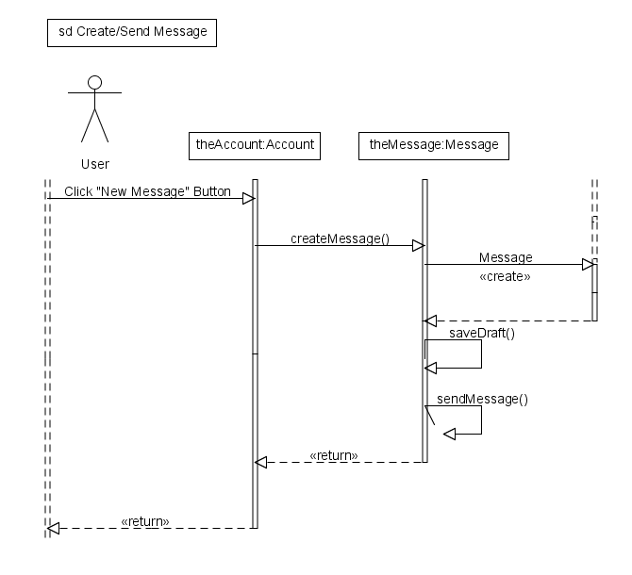
Fig 3.3.1: Sequence diagram for principle action Create Message

3.4. Principle Action: Change/Reset Password

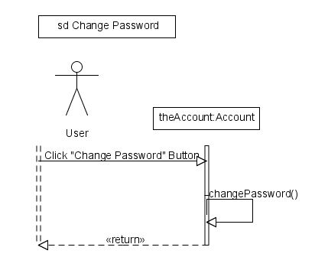
Fig 3.4.1: Sequence diagram for principle action Change Password

3.5. Principle Action: Create SLAPs, Instructor to Student, Administrator to All, Administrator to Instructor
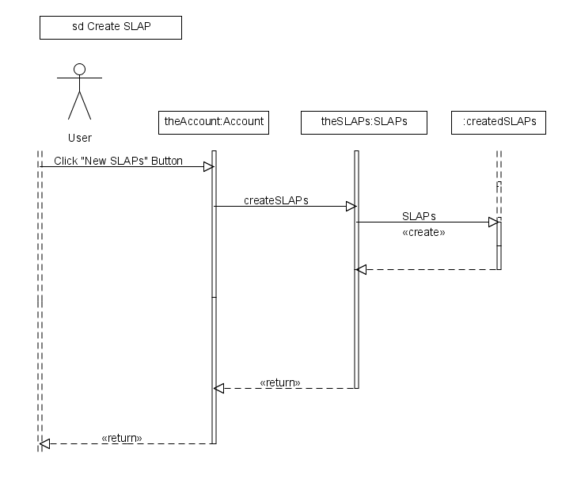
Fig 3.5.1: Sequence diagram for principle action Create SLAPs

3.6. Principle Action: Submit Evaluations/Assignments
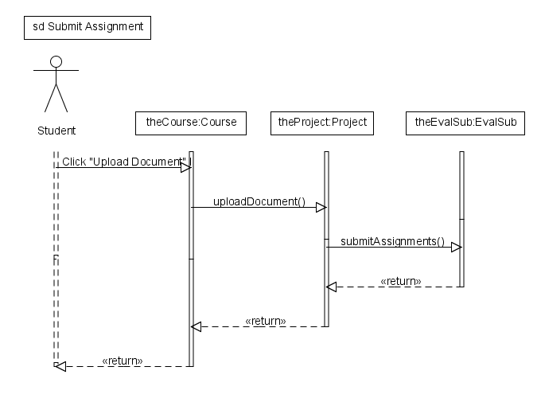
Fig 3.6.1: Sequence diagram for principle action Submit Assignment

4. Detail Design Specification:
The following is a list of main classes and their attributes and methods with proper comments.
- class Security{
//attributes//
String username; //stores user input of username
String password; //stores user input of password
//methods//
void validateUser(String username, String password); //checks to validate user
}
- class Project{
//attributes//
String projectName[]; //stores the project name
String instruction[]; //stores the project instructions
//methods//
void createProject(String projectName, String instructions); //create a new project
void editProject(String projectName, String instructions); //edit a project
void cancelProject(String projectName, String instructions); //cancel a project
void discardChange(String projectName, String instructions); //discard changes in project
void viewProject(String projectName); //display project
void uploadDocument(String instructions); //uploads instructions
void viewDocument(String instructions); //display instructions
void closeDocument( ); //close instructions display
void cancelView( ); //close project display
}
- class Groups{
//attributes//
String students[]; //stores student names
String groups[][]; //stores group members
//methods//
void assignGroup(String students, String groups); //assign students to a group
void editGroup(String students, String groups); //edit group members
void deleteGroup(String students, String groups); //delete a group
void viewActivity( ); //display a student activity
}
- class Course{
//attributes//
String courseName[]; //stores course names
String courseCode[]; //stores course codes
//methods//
void createCourse(String courseName, String courseCode); //create a new course
void editCourse(String courseName, String courseCode); //edit a course
void deleteCourse(String courseName, String courseCode); //delete a course
void viewCourse(String courseName, String courseCode); //display a course
}
- class Message{
//attributes//
String message; //stores message
String draft; //stores draft of message
//methods//
void createMessage(String message); //create a new message
void editMessage(String message); //edit a message
void saveDraft(String message, String draft); //saves message as draft
void sendMessage(String message); //sends message
void cancelMessage(String message); //cancels a message
void viewMessage(String message); //display a message
void closeMessage(String message); //close display of message
}
- class SLAPs{
//attributes//
String InstructortoStudentStatement; stores a statement (Instructor to Student)
String AdmintoAllStatement; stores a statement (Admin to All)
String AdmintoInstructorStatement; //stores a statement (Admin to Instructor)
//methods//
void createInstructortoStudent(String InstructortoStudentStatement);
//creates a new statement (Instructor to Student)
void createAdmintoAll(String InstructortoAll);
//creates a new statement (Admin to All)
void createAdmintoInstructor(String AdmintoInstructor);
//create a new statement (Admin to Instructor)
void editInstructortoStudent(String InstructortoStudent);
//edit statement (Instrucor to Student)
void editAdmintoAll(String Admin to All);
//edit statement (Admin to All)
void editAdmintoInstructor(String AdmintoInstructor);
//edit statement (Admin to Instructor)
}
- class Account{
//attributes//
String username; //stores username
String password; //stores password
String contacts[]; //stores contacts
//methods//
void changePassword(String password); //changes password
void resetPassword(String password); //resets password
void registerUser(String username); //registers a new user
void reorganizeContacts(String contacts); //organizes contacts
}
- class EvalSub{
//methods//
void viewSubmissions( );
void viewSubmissionHistory( ); //display submission history
void submitEvaluations( ); submits a evaluation
void submitAssignments( ); //submits an assignment
}
- class GUI{
//methods//
void createGUI( ); //create the graphical interface
}

